Focus of the Lesson: How do historians use primary source documents?
Common Core Learning Standards:
- W.3.2: Write informative/explanatory texts to examine a topic and convey ideas and information clearly.
- SL.3.1: Engage effectively in a range of collaborative discussions (one-on-one, in groups, and teacher-led) with diverse partners on grade 3 topics and texts, building on others’ ideas and expressing their own clearly.
- RI.3.3: Describe the relationship between a series of historical events, scientific ideas or concepts, or steps in technical procedures in a text, using language that pertains to time, sequence, and cause/effect.
- RI.3.7: Use information gained from illustrations (e.g., maps, photographs) and the words in a text to demonstrate understanding of the text (e.g., where, when, why, and how key events occur).

Additional Standards and/or Scope and Sequence:
- Common Core Learning Standards (CCLS) implement “standards for K–5 reading in history/social studies, science, and technical subjects are integrated into the K–5 Reading standards.” Please visit the CCLS home page for further information (http://www.corestandards.org/). For further guidance and alignment, please see the NYS Social Studies Standards and NYC Social Studies Scope and Sequence, which are accessible from the HPSBG website.

Connection to Prior Teaching: This lesson addresses some of the tools that historians utilize for analyzing historical documents by differentiating between primary source and secondary source documents. This lesson should be utilized as a follow up to activating students’ prior knowledge about the local neighborhood of Hunts Point. Students should be able to recognize information about Hunts Point, such as street names, store names, and neighborhood locations such as parks, etc. Students should be able to understand that Hunts Point has a long history that they will continue to investigate. Students will benefit from multiple opportunities for exploration and documentations outside the school within the community.
Materials/Resources/Readings:
- So, What Can I Learn From This______________? Graphic Organizer (copy double sided to allow analysis of two documents on one paper)
  - NOTE: This graphic organizer was adapted from the National Archives ‘Photo Analysis Worksheet’ (http://www.archives.gov/education/lessons/worksheets/photo.html)
- HPSBG Historical Photographs and Maps
  - “Hunts Point Drake Park, 1915”
  - “Bronx 1897 U.S. Coastal Topographical Map”
  - “Federal Census, 1790”
  - “”NYPL Map, 1888”
  - “Slave Burying Ground, MCNY, Hunts Point Road, ca.1910”
- Chart paper and markers
- Focus Lens (attached, or simply cut out one fourth of an 8.5” x 11” piece of paper)
  - Allows students to focus on a small part of the document at one time

Lesson Procedure:
- Introduction:
  - Begin the lesson with a “do now” that reviews and activates prior knowledge. For example, students develop a quick write on a slip paper that responds to the following the question, “What information do you already know about Hunts Point?”
  - Conclude this do now by allowing students to share the information that they wrote. Record the information that students share on chart paper (or electronically) to revisit and deepen student understanding about Hunts Point and the Hunts Point Slave Burial Ground (HPSBG) Project.

- Guided Practice:
  - Model how to analyze and determine the type and purpose of the document types that will be utilized during this lesson.
    - Display one primary source document. Model thinking aloud, and recording observations within the first column of the attached graphic organizer. List the type of document [census, photograph, topographical map, street map].
    - Focus on observable, low inference information about the entire document, such as, “This is a photograph,” or “I see a house with a porch,” [Hunts Point Drake Park, 1915].
    - Introduce the “Focus Lens” by viewing one quadrant of the document. Model looking closely and recording additional details. Demonstrate discovery of new information by closely analyzing the document. Then rotate the “focus lens” to view another quadrant of the document.
  - Display the documents that will be explored in small groups.
    - As an overview, ask students to observe each document type and discuss in small groups, “What type of information can this document teach us?” Lead the discussion through the student language to highlight the following:
      - Photograph: an image recorded by a camera that shows a “snapshot,” or single moment in time
      - Topographical map: a map that shows how high and low the land is (elevation) as well as the different types of land features
      - Census: a counting, or tallying, of the names and number of people living in a certain area at a certain time
      - Street map: a map that shows the streets in an area
  - Introduce the term, “primary source.” Ask the students, “When do you think these documents were created?”
    - Allow a range of answers that lead students to determine for themselves that these documents are historic. The documents are from before they were born, which we call “modern times.”
    - Highlight the word “primary” because these documents were created during a historic time period that we are studying that help us today learn about life during that time.
    - This discussion of the past could elicit many questions about the past. Foster these questions by allowing students to record their questions on chart paper, as well as on their graphic organizer in the second column.

- Independent Exploration:
  - Arrange students into small groups. Provide each group with the following:
    - A HPSBG primary source document
    - A “focus lens”
    - 2 copies for each student of the So, What Can I Learn From This______________? Graphic Organizer and pencil
  - Circulate amongst the students to observe the information that students gather.
    - Model and introduce sentence patterns and vocabulary, such as “primary source,” “photograph,” “topographical map,” “street map,” census,” “examine” and “observe.”
    - Ensure that students actively discuss their observations, record information in the graphic organizer’s first column, and look closely for objective information.
  - Rotate documents amongst students. Repeat. Continue every few minutes (based on student engagement) until each of the four documents has been explored.

- Differentiation:
  - Utilize sentence starters for students who need assistance in their sentence structures.
    - Ex. In this ____(document type), I observe _______. / I see a ___________.
  - Display the enlarged graphic organizer for students to visualize the process for completing the graphic organizer.

- Summary and Share
  - Assign one of documents for each group to share the information they discovered. Students must present the information as if they are “historians” that will respond to questions from “reporters.” The reporters will be the rest of the class, who should ask questions such as, “What did you learn from this document?” or “What else did you learn from this document?” Assist students in formulating questions that force “historians” to elaborate beyond “yes” or “no.”
  - Allow a reflection time where students add information to the second column (“What questions do I now have about Hunts Point?”) and the third column (“Where could I find answers about my questions?”) of their graphic organizer.

Assessment: Teacher will look at students’ graphic organizers for the following: a) organization of writing; b) ability to close analyze a document; and c) finding a hook to introduce additional HPSBG topics. For example, the second and third column of the graphic organizer will provide hooks for future lessons that engage students in historical research.
Follow Up: Introduce additional HPSBG topographical map, street map, census, and photograph primary source documents to students to analyze the historic time periods involved in this project. Introduce the dates for each of these documents to allow students to create a timeline from most recent to most historic.
Attached Resources: See attached HPSBG primary source documents, graphic organizer, and “focus lens.”
Directions: You will observe a primary source document about Hunts Point. A primary source is a document that was made during the period in history that your are researching. Look at the entire document. Record what you observe in the first column. Then we will look more closely. Continue recording your observations. Next, think about the questions you now have about Hunts Point. Write these questions in the second column. Last, plan how you will find answers in the third column.

What do I observe in this ________________________? | What questions do I now have about Hunts Point? | Where could I find answers about my questions?
**Think about people, objects, and activities. | **Think about what you wonder. | **Think about where you locate information.
Document Citation: _______________________________________________________________________________________________________________________________
Cut out this part of the paper.
Hint: Just use scrap paper!!! ☺

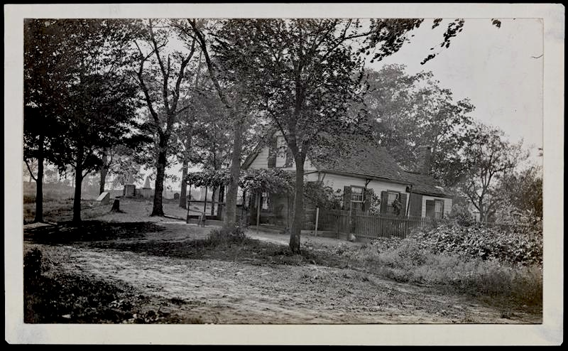
Hunt Point Drake Park, 1915
Bronx 1897 U.S. Coastal Topographical Map
Federal Census, 1790
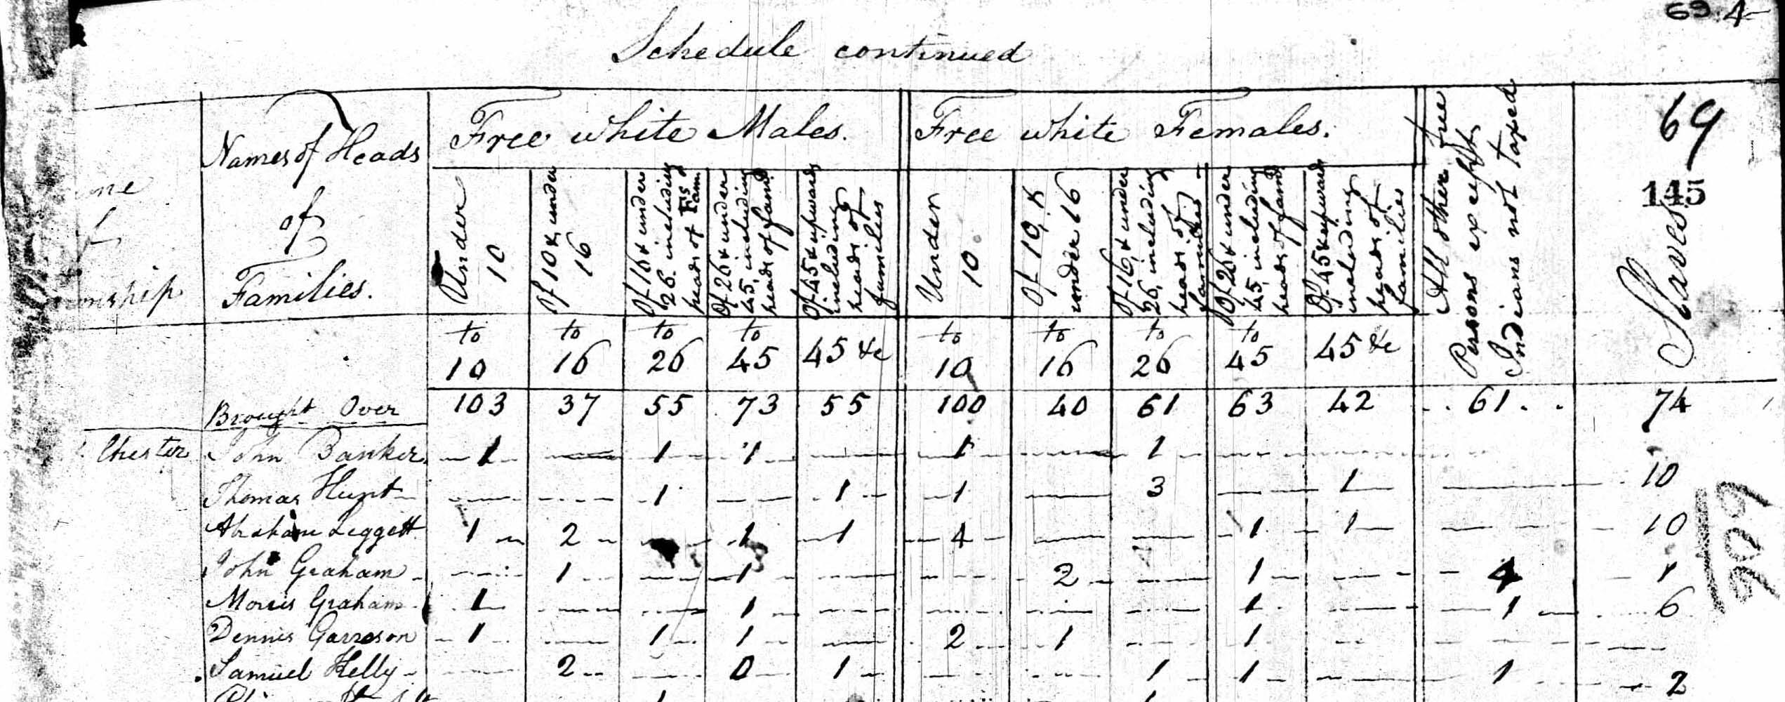

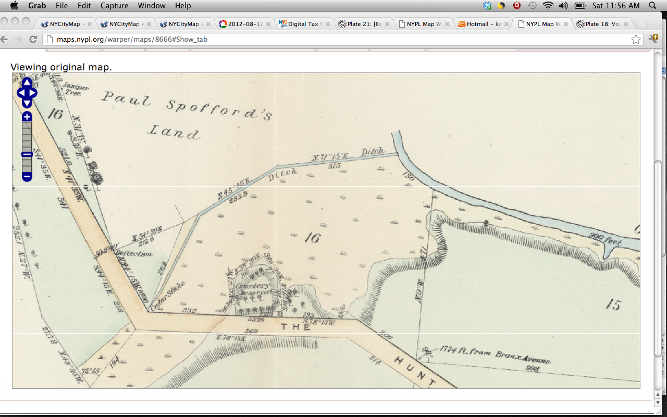
NYPL Map, 1888
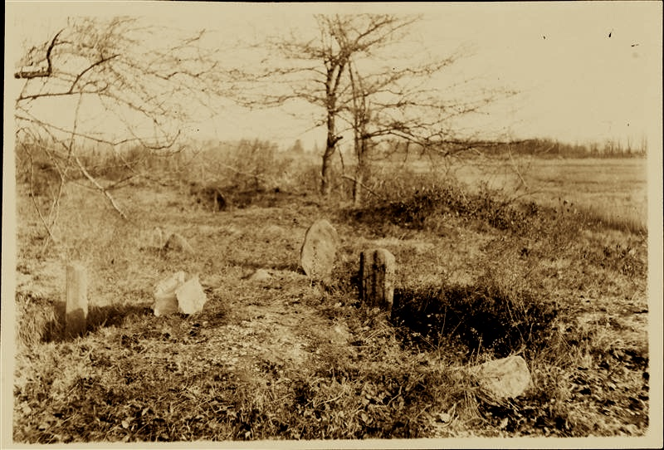
Slave Burying Ground, MCNY, Hunts Point Road, ca. 1910
Hunts Point Drake Park 1915 1

