Joseph Rodman Drake Cemetery Investigation
Field Experience Data Gathering Sheet
http://hpsbg.weebly.com/

If you happen to get lost, call me at (XXX) XXX-XXXX. Remember the school contact information too!
P.S. 48
1290 Spofford Ave.
Bronx, NY 10474
(718) 589-4312

Remember, you are a historian! Today you will be conducting field research inside the Drake Cemetery. As you investigate the area, remember to document your investigation using this data gathering sheet, your iPad (for photographs and video), archival gloves, a compass, and the other tools that have been provided.

Important Words to Utilize
cemetery | grave | tombstone
inscription | topography | fence
burial | plot | base (bottom)

Date__________________ Time ___________ Weather ___________________

1. What do you observe inside the fenced area within the boundary of Drake Park? Think about objects, topography, plant life, and so on.

2. Locate a circular fence in the cemetery. What is going on here? Why would they have this fence? Look at the 1915 Photograph for help.
Think about: the objects and the importance of the fence

3. Select a tombstone to investigate closely. Carefully view the tombstone.
- What do you observe about the stone itself?
Think about these words: rough, smooth, color, and size.

- What do you learn from the inscription?
Think about: the year, names, dedication, and artistic designs.

- What does this tombstone make you wonder?
Think about: the person’s life and descendants or the local history you know.
4. Locate a large oak tree near the perimeter of the cemetery. What do you discover at the base of the tree? Draw and write your observations.
Think about: the words on the inscription and why this object is here.

5. Compare the cemetery in the historic photographs to the cemetery you see today. How has the cemetery changed over the years?

Historic Images of the Cemetery | Modern View of the Cemetery

6. Record photographs and video for your investigation. Some ideas to consider:

  - Be a reporter. Tell your audience what you are doing in the cemetery.

  - Record short video clips. Short and sweet makes for better films!

  - Think about historic information you have learned. What images can you take today that will help you with your final project?

Use this compass to understand which geographic direction we face as we walk from PS 48 to the Drake Cemetery and back from Drake Cemetery to PS 48.

North

East
West

South

Definitions for Important Words to Utilize

Cemetery- a spatially defined area where the remains of dead people are buried

Inscription - writing on a stone

Burial or interment- the ritual act of placing a dead person or animal, and/or objects into the ground

Grave - a place of burial for a dead body, typically a hole dug in the ground and marked by a stone or mound

Topography - the arrangement of the natural and artificial physical features of an area

Plot - a piece of property within a cemetery purchased for a burial

Tombstone -A large, flat inscribed stone standing or laid over a grave

Fence - a barrier, railing, or other upright structure, typically of wood or wire, enclosing an area of ground to mark a boundary

Base - lowest part or edge of something, esp. the part on which it rests or is supported
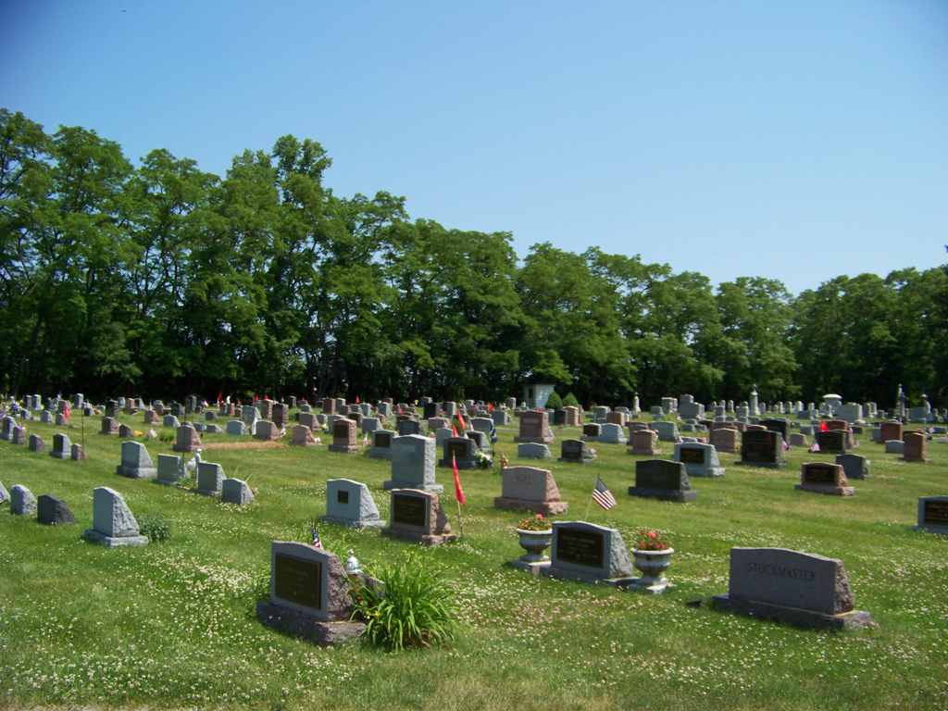
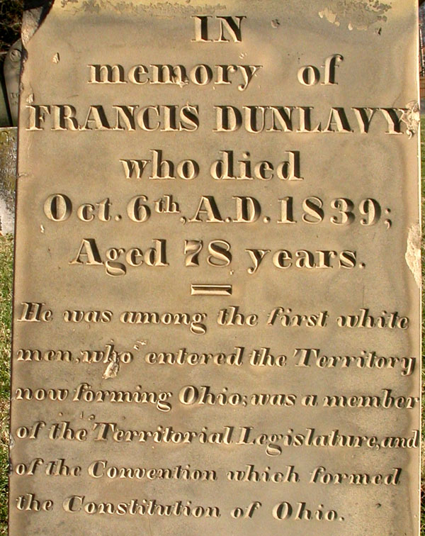
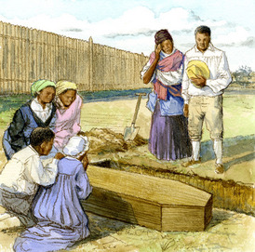
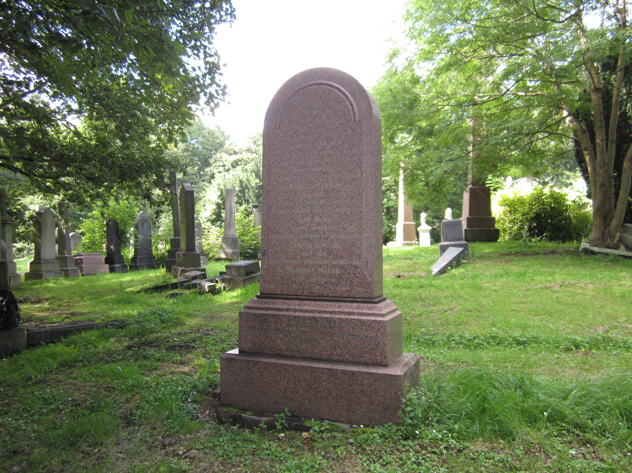
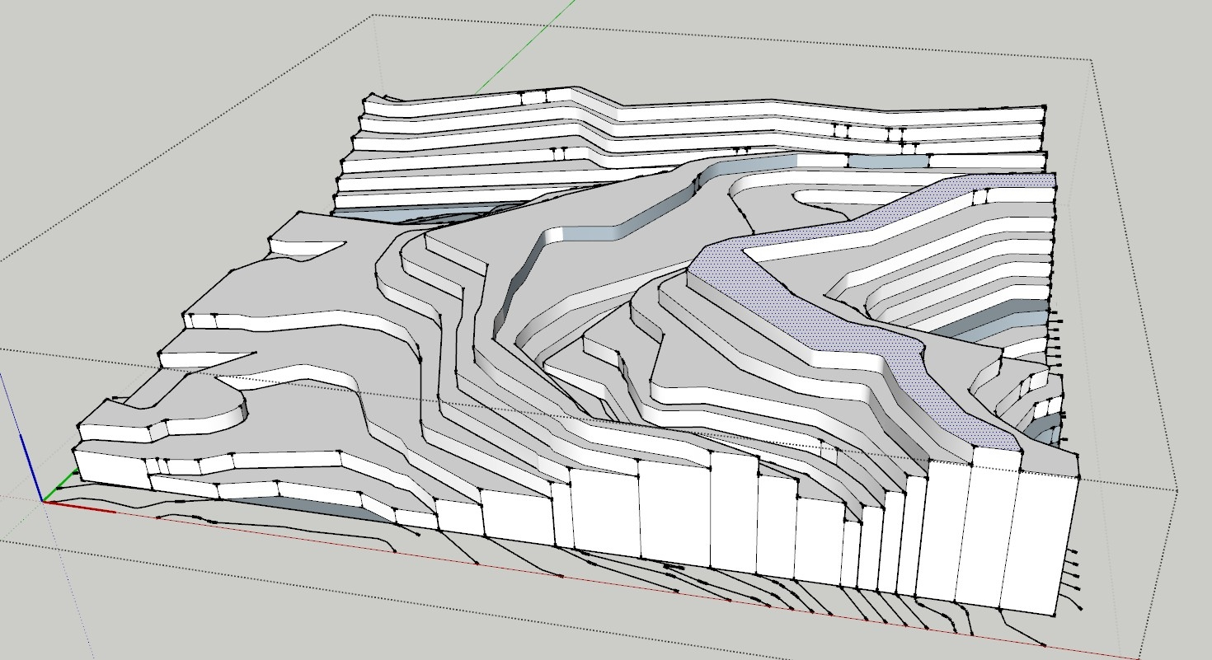
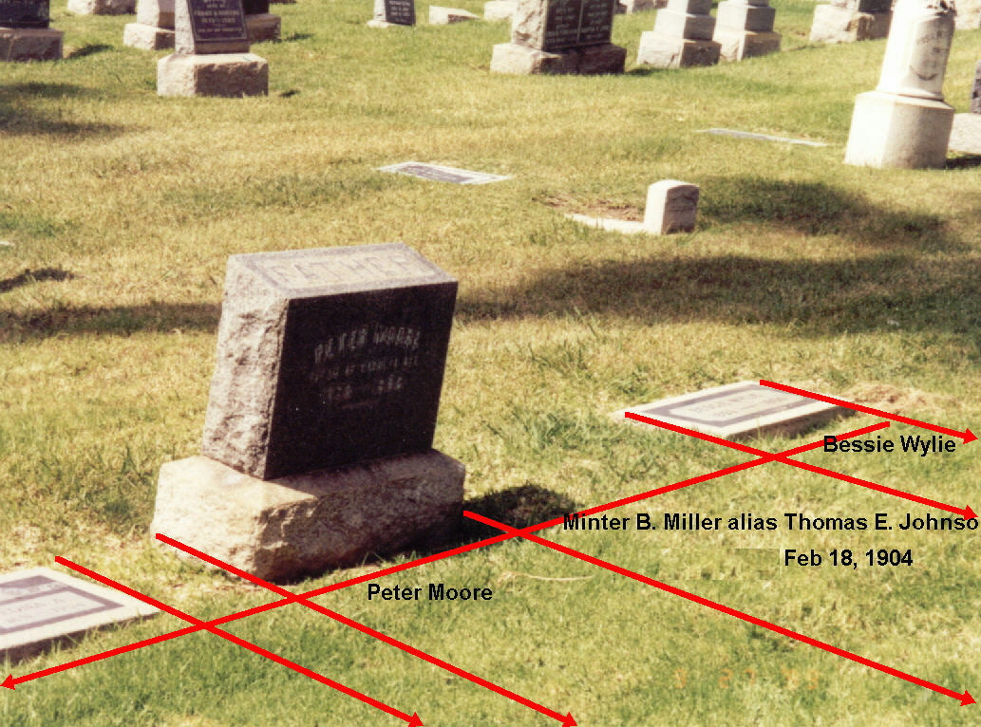
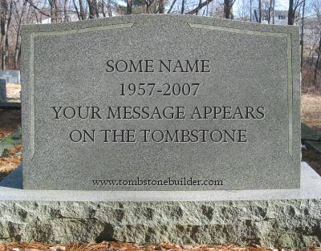
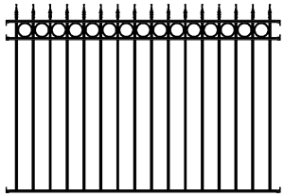
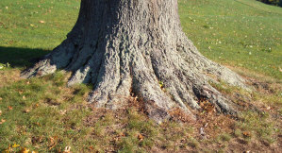
cemetery
inscription
burial
grave
topography
plot
tombstone
fence
base

